**Development of Data Distribution Plan:**

The objective is to explain how data can be distributed into two databases using database linking. We have Database name as “**Hospital_DB**”. So, we distribute the database as “**Hospital_DB_1**” and “**Hospital_DB_2**”. These two databases have to be linked.

**Steps:**

There are some steps that need to be performed for data distribution, such as:

* Create four (we have 6) tables on **Hospital_DB_1** database
* Identify a table to be fragmented horizontally
* Insert data into the tables based on the fragmented strategy

**Data Model creation:**

**Patients**

|  |  |  |  |  |  |  |  |
| --- | --- | --- | --- | --- | --- | --- | --- |
| Patient_ID | First_Name | Last_Name | DOB | Phone | Gender | Address | Zip |
| 1 | John | Fedric | 2-8-1980 | 143242 | M | 23 block | 145 |
| 2 | Aaron | Hank | 13-4-1994 | 144423 | M | 99 city | 78 |
| 3 | Abbey | Edward | 18-6-1984 | 924598 | F | Main 2A | 342 |
| 4 | Abelson | Hall | 22-3-1982 | 786290 | F | 13-B sid | 366 |
| 5 | Bob | Lee | 23-8-2001 | 698399 | M | Street 14 | 42 |
| 6 | Dawane | Bravo | 16-9-1990 | 359086 | M | 19 A city | 65 |
| 7 | Andrew | Stall | 5-12-1998 | 342508 | M | 52 belon | 776 |
| 8 | Stella | Queen | 14-7-1992 | 566376 | F | Wagha 4 | 645 |

**Visit**

|  |  |  |  |  |  |
| --- | --- | --- | --- | --- | --- |
| Visit_ID | Patient_ID | Provider_ID | Notes | Purpose | Hospital_CCN_ID |
| 1 | 3 | 2 | Injured | Cure | 001 |
| 2 | 6 | 1 | Sick | Leave | 002 |
| 3 | 8 | 3 | Sugar | Cure | 003 |
| 4 | 2 | 3 | Bypass | Cure | 001 |

**Hospital**

|  |  |  |  |  |
| --- | --- | --- | --- | --- |
| Hospital_CCN_ID | Phone_Num | Address | Zip_Code | CMS_Region |
| 001 | 3245561 | 23 A main | 54039 | West |
| 002 | 1454315 | City Block 2 | 49051 | North |
| 003 | 5214234 | Bolvard 75 | 54000 | North |

**Provider**

|  |  |  |  |  |  |
| --- | --- | --- | --- | --- | --- |
| Provider_ID | Hospital_CCN_ID | First_Name | Last_Name | Phone_Num | Specialty |
| 1 | 002 | Fedrick | Hudge | 1251235 | Heart |
| 2 | 001 | Alisa | Barone | 1235234 | Surgeon |
| 3 | 003 | Kelvin | Thomas | 2345342 | Analyst |

**Prescriptions**

|  |  |  |  |  |  |
| --- | --- | --- | --- | --- | --- |
| Visit_ID | Medication_ID | Provider_ID | Qty | Prescription_Num | Pharmary_Num |
| 1 | 101 | 2 | 22 | 1 | 012 |
| 2 | 102 | 3 | 34 | 2 | 013 |
| 3 | 103 | 1 | 54 | 3 | 014 |

**Medications**

|  |  |  |
| --- | --- | --- |
| Medication_ID | Name | Dose |
| 101 | Panadol | 2 time |
| 102 | Elcid | 1 time |
| 103 | Kalaricid | 1 time |

**Note:**

We select Patients Table for the fragmentation.

Using the above horizontal fragmentation strategy, we will split the data between the two databases as follows:

|  |  |  |  |  |  |  |  |  |
| --- | --- | --- | --- | --- | --- | --- | --- | --- |
| ID | First_Name | Last_Name | DOB | Phone | Gender | Address | Zip | DB |
| 1 | John | Fedric | 2-8-1980 | 143242 | M | 23 block | 145 | Hospital_DB_1 |
| 2 | Aaron | Hank | 13-4-1994 | 144423 | M | 99 city | 78 | Hospital_DB_1 |
| 3 | Abbey | Edward | 18-6-1984 | 924598 | F | Main 2A | 342 | Hospital_DB_1 |
| 4 | Abelson | Hall | 22-3-1982 | 786290 | F | 13-B sid | 366 | Hospital_DB_1 |
| 5 | Bob | Lee | 23-8-2001 | 698399 | M | Street 14 | 42 | Hospital_DB_2 |
| 6 | Dawane | Bravo | 16-9-1990 | 359086 | M | 19 A city | 65 | Hospital_DB_2 |
| 7 | Andrew | Stall | 5-12-1998 | 342508 | M | 52 belon | 776 | Hospital_DB_2 |
| 8 | Stella | Queen | 14-7-1992 | 566376 | F | Wagha 4 | 645 | Hospital_DB_2 |

Using the above horizontal fragmentation strategy, we will split the data between the two databases as follows:

|  |  |  |  |  |  |  |  |  |
| --- | --- | --- | --- | --- | --- | --- | --- | --- |
| ID | First_Name | Last_Name | DOB | Phone | Gender | Address | Zip | DB |
| 1 | John | Fedric | 2-8-1980 | 143242 | M | 23 block | 145 | Hospital_DB_1 |
| 2 | Aaron | Hank | 13-4-1994 | 144423 | M | 99 city | 78 | Hospital_DB_1 |
| 3 | Abbey | Edward | 18-6-1984 | 924598 | F | Main 2A | 342 | Hospital_DB_1 |
| 4 | Abelson | Hall | 22-3-1982 | 786290 | F | 13-B sid | 366 | Hospital_DB_1 |

|  |  |  |  |  |  |  |  |  |
| --- | --- | --- | --- | --- | --- | --- | --- | --- |
| ID | First_Name | Last_Name | DOB | Phone | Gender | Address | Zip | DB |
| 5 | Bob | Lee | 23-8-2001 | 698399 | M | Street 14 | 42 | Hospital_DB_2 |
| 6 | Dawane | Bravo | 16-9-1990 | 359086 | M | 19 A city | 65 | Hospital_DB_2 |
| 7 | Andrew | Stall | 5-12-1998 | 342508 | M | 52 belon | 776 | Hospital_DB_2 |
| 8 | Stella | Queen | 14-7-1992 | 566376 | F | Wagha 4 | 645 | Hospital_DB_2 |

**Step 1:**

Create four (we have 6) tables on **Hospital_DB_1** database.

Execute the following DDL script:

Create database Hospital_DB_1;

Use Hospital_DB_1;

CREATE TABLE Patients (

Patient_ID INT NOT NULL,

First_Name varchar(50) NOT NULL,

Last_Name varchar(50) NOT NULL,

DOB DATE NOT NULL,

Phone_Num varchar(50) NOT NULL,

Gender varchar(2) NOT NULL,

Address varchar(50) NOT NULL,

Zip_Code varchar(50) NOT NULL,

Database_Name varchar(50) NOT NULL

);

CREATE TABLE Visits (

Visit_ID INT NOT NULL,

Patient_ID INT NOT NULL,

Provider_ID INT NOT NULL,

Notes varchar(50) NOT NULL,

Purpose varchar(50) NOT NULL,

Hospital_CCN_ID INT NOT NULL

);

CREATE TABLE Hospitals (

Visit_ID INT NOT NULL,

Patient_ID INT NOT NULL,

Provider_ID INT NOT NULL,

Notes varchar(50) NOT NULL,

Purpose varchar(50) NOT NULL,

Hospital_CCN_ID INT NOT NULL

);

CREATE TABLE Provider (

Provider_ID INT NOT NULL,

Hospital_CCN_ID INT NOT NULL,

First_Name varchar(50) NOT NULL,

Last_Name varchar(50) NOT NULL,

Phone_Num varchar(50) NOT NULL,

Specialty varchar(50) NOT NULL

);

CREATE TABLE Prescriptions (

Visit_ID INT NOT NULL,

Medication_ID INT NOT NULL,

Provider_ID INT NOT NULL,

Qty INT NOT NULL,

Prescription_Num INT NOT NULL,

Pharmary_Num INT NOT NULL

);

CREATE TABLE Medications (

Medication_ID INT NOT NULL,

Name varchar(50) NOT NULL,

Dose varchar(50) NOT NULL

);

**Screenshot of working queries:**

**Screenshot 1:**

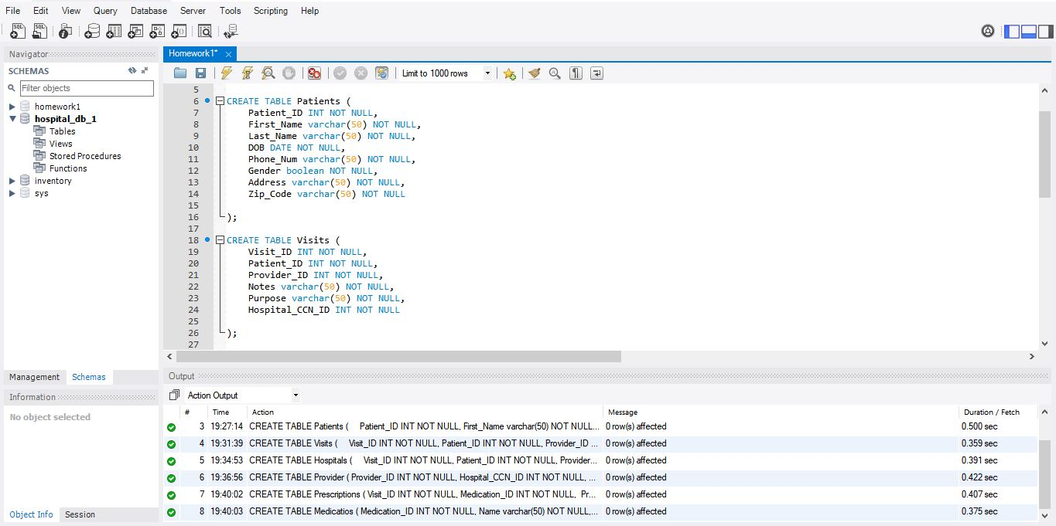

**Screenshot 2:**

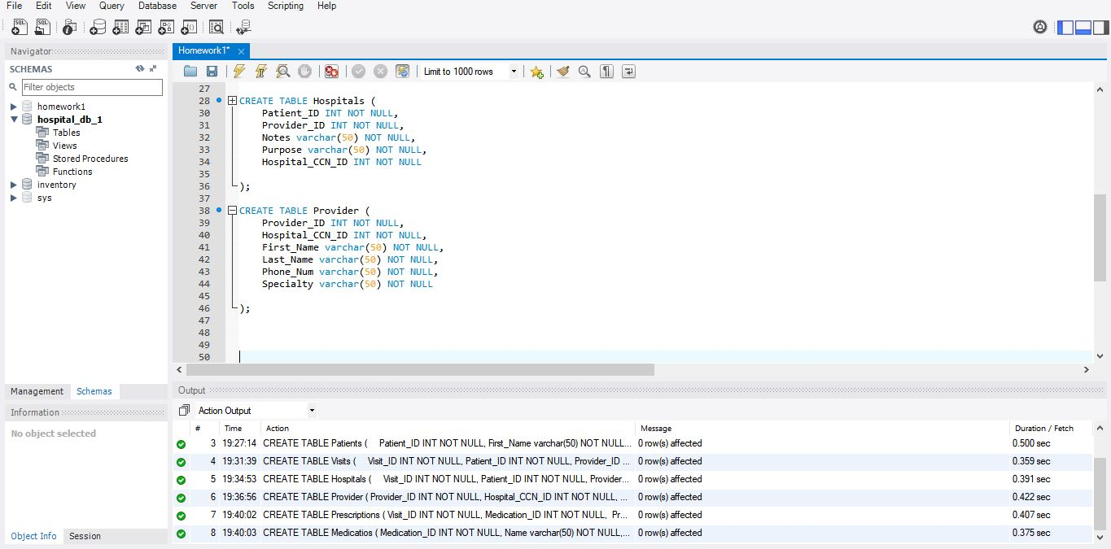

**Screenshot 3:**

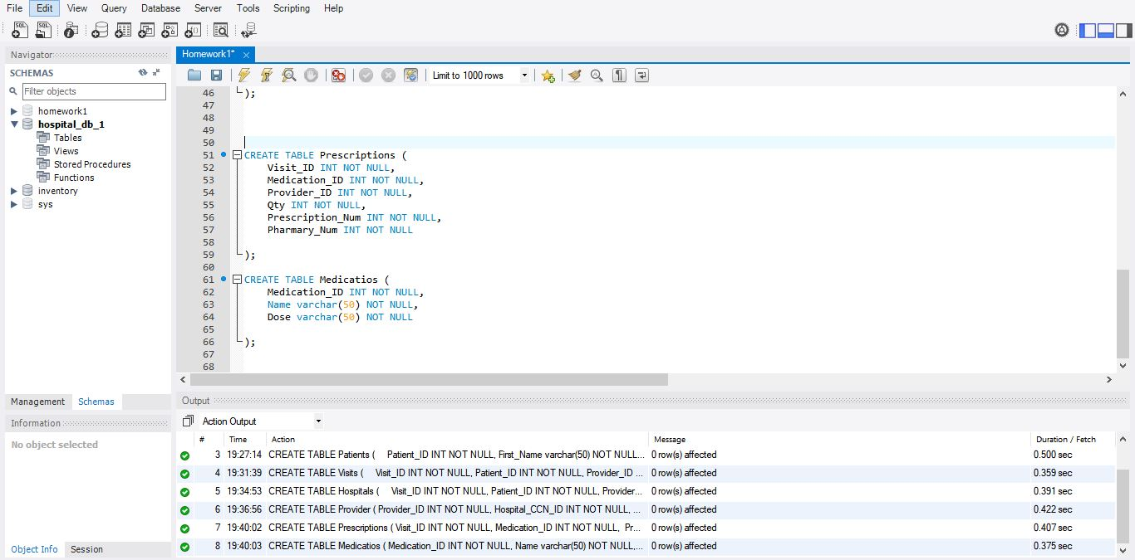

**Creation of Hospital_DB_2:**

Create four (we have 6) tables on **Hospital_DB_2** database.

Execute the following DDL script:

Create database Hospital_DB_2;

Use Hospital_DB_2;

CREATE TABLE Patients (

Patient_ID INT NOT NULL,

First_Name varchar(50) NOT NULL,

Last_Name varchar(50) NOT NULL,

DOB DATE NOT NULL,

Phone_Num varchar(50) NOT NULL,

Gender varchar(2) NOT NULL,

Address varchar(50) NOT NULL,

Zip_Code varchar(50) NOT NULL,

Database_Name varchar(50) NOT NULL

);

CREATE TABLE Visits (

Visit_ID INT NOT NULL,

Patient_ID INT NOT NULL,

Provider_ID INT NOT NULL,

Notes varchar(50) NOT NULL,

Purpose varchar(50) NOT NULL,

Hospital_CCN_ID INT NOT NULL

);

CREATE TABLE Hospitals (

Visit_ID INT NOT NULL,

Patient_ID INT NOT NULL,

Provider_ID INT NOT NULL,

Notes varchar(50) NOT NULL,

Purpose varchar(50) NOT NULL,

Hospital_CCN_ID INT NOT NULL

);

CREATE TABLE Provider (

Provider_ID INT NOT NULL,

Hospital_CCN_ID INT NOT NULL,

First_Name varchar(50) NOT NULL,

Last_Name varchar(50) NOT NULL,

Phone_Num varchar(50) NOT NULL,

Specialty varchar(50) NOT NULL

);

CREATE TABLE Prescriptions (

Visit_ID INT NOT NULL,

Medication_ID INT NOT NULL,

Provider_ID INT NOT NULL,

Qty INT NOT NULL,

Prescription_Num INT NOT NULL,

Pharmary_Num INT NOT NULL

);

CREATE TABLE Medications (

Medication_ID INT NOT NULL,

Name varchar(50) NOT NULL,

Dose varchar(50) NOT NULL

);

**Step 2:**

Identify a table to be fragmented horizontally.

We will fragment the Patient table as follows:

**Patient1 = sID < “4” (Patients)**

**Patient 2 = sID > “4” (Patients)**

Using the above horizontal fragmentation strategy, we’ll split the data between the two databases as following:

|  |  |  |  |  |  |  |  |  |
| --- | --- | --- | --- | --- | --- | --- | --- | --- |
| ID | First_Name | Last_Name | DOB | Phone | Gender | Address | Zip | DB |
| 1 | John | Fedric | 2-8-1980 | 143242 | M | 23 block | 145 | Hospital_DB_1 |
| 2 | Aaron | Hank | 13-4-1994 | 144423 | M | 99 city | 78 | Hospital_DB_1 |
| 3 | Abbey | Edward | 18-6-1984 | 924598 | F | Main 2A | 342 | Hospital_DB_1 |
| 4 | Abelson | Hall | 22-3-1982 | 786290 | F | 13-B sid | 366 | Hospital_DB_1 |

|  |  |  |  |  |  |  |  |  |
| --- | --- | --- | --- | --- | --- | --- | --- | --- |
| ID | First_Name | Last_Name | DOB | Phone | Gender | Address | Zip | DB |
| 5 | Bob | Lee | 23-8-2001 | 698399 | M | Street 14 | 42 | Hospital_DB_2 |
| 6 | Dawane | Bravo | 16-9-1990 | 359086 | M | 19 A city | 65 | Hospital_DB_2 |
| 7 | Andrew | Stall | 5-12-1998 | 342508 | M | 52 belon | 776 | Hospital_DB_2 |
| 8 | Stella | Queen | 14-7-1992 | 566376 | F | Wagha 4 | 645 | Hospital_DB_2 |

**STEP3:**

Insert data into the tables based on the fragmented strategy.

In order to split the data between the two databases, **Hospital_DB_1** and **Hospital_DB_2**, we’ll need to use a database link to access the two databases. Here is the syntax to create the database link named Linker_1_2.

CREATE DATABASE LINK Linker_1_2 CONNECT TO system IDENTIFIED BY "***0racl3Admin***" USING 'Hospital_DB_2';

Type the following statement to verify that you have successfully created the database link.

SELECT * FROM DUAL@Linker_1_2;

Enter the following DML statement to insert data into **Hospital_DB_1.**

INSERT INTO Patients (Patient_ID,First_Name,Last_Name,DOB,Phone_Num,Gender,Address,Zip_Code,Database_Name)

VALUES ( '1','John','Fedric','1980-8-13','143242','M','23 block','145','hospital_db_1');

INSERT INTO Patients (Patient_ID,First_Name,Last_Name,DOB,Phone_Num,Gender,Address,Zip_Code,Database_Name)

VALUES ( '2', 'Aaron', 'Hank', '1994-4-13', '144423', 'M', '99 city', '78', 'hospital_db_1');

INSERT INTO Patients (Patient_ID,First_Name,Last_Name,DOB,Phone_Num,Gender,Address,Zip_Code,Database_Name)

VALUES ( '3', 'Abbey', 'Edward', '1984-6-18', '924598', 'F', 'Main 2A', '342', 'hospital_db_1');

INSERT INTO Patients (Patient_ID,First_Name,Last_Name,DOB,Phone_Num,Gender,Address,Zip_Code,Database_Name)

VALUES ( '4', 'Abelson', 'Hall', '1982-3-22', '786290', 'F', '13-B sid' ,'366', 'hospital_db_1');

**Screenshot:**

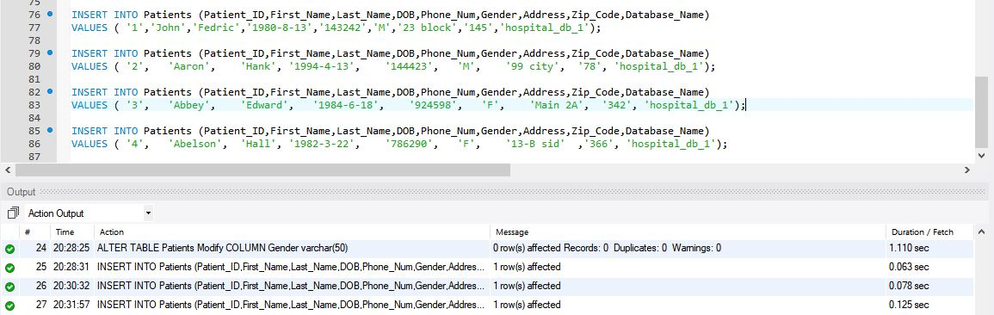

**Results:**

To check the database data, execute the query into it.

SELECT * from Patients;

**Screenshot:**

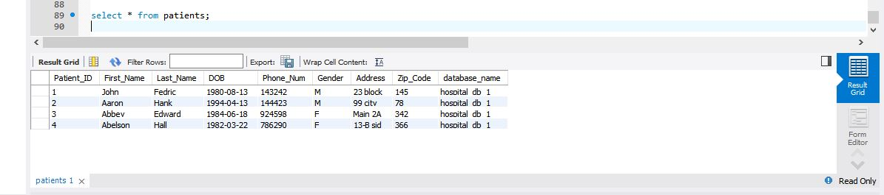

Enter the following DML statement on **‘Hospital_DB_1’** to insert data into **‘Hospital_DB_2’**.

INSERT INTO Patients@Linker_1_2 (Patient_ID,First_Name,Last_Name,DOB,Phone_Num,Gender,Address,Zip_Code,Database_Name)

VALUES ('5', 'Bob', 'Lee', '2001-8-12', '698399', 'M', 'Street 14', '42','hospital_db_2');

INSERT INTO Patients@Linker_1_2 (Patient_ID,First_Name,Last_Name,DOB,Phone_Num,Gender,Address,Zip_Code,Database_Name)

VALUES ('6', 'Dawane', 'Bravo', '1990-9-16', '359086', 'M', '19 A city', '65','hospital_db_2');

INSERT INTO Patients@Linker_1_2 (Patient_ID,First_Name,Last_Name,DOB,Phone_Num,Gender,Address,Zip_Code,Database_Name)

VALUES ('7', 'Andrew’, ‘Stall', '1998-12-5', '342508', 'M', '52 belon', '776','hospital_db_2');

INSERT INTO Patients@Linker_1_2 (Patient_ID,First_Name,Last_Name,DOB,Phone_Num,Gender,Address,Zip_Code,Database_Name)

VALUES ('8', 'Stella', 'Queen', '1992-7-14', '566376', 'F', 'Wagha 4', '645','hospital_db_2');

**Screenshots:**

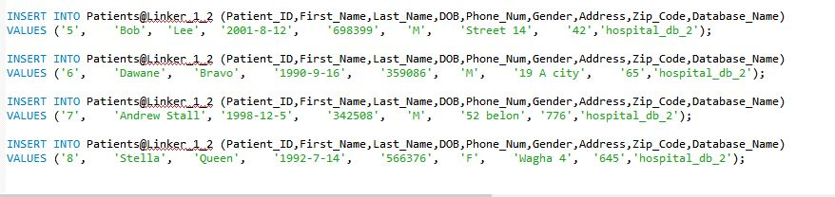

**Results:**

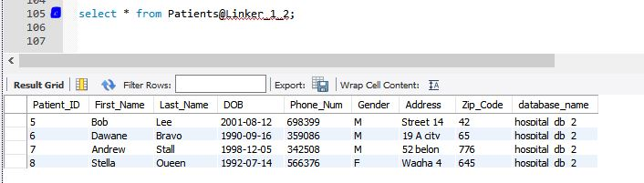

**VIEWS:**

Create a view joining the two tables from both databases.

CREATE OR REPLACE VIEW all_patient_view AS

SELECT * FROM patient;

**UNION:**

Create a Union from both databases.

SELECT * FROM all_ patient _view;

**Screenshot:**

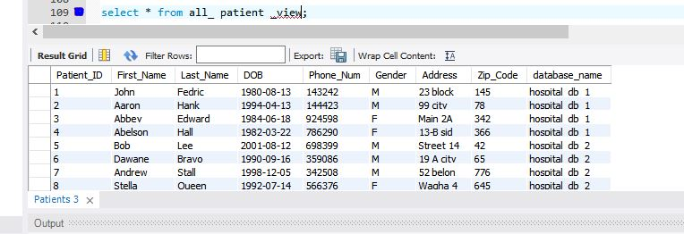

**Queries with results:**

**Query 1:**

Select *

from all_ patient _view

where Patient_ID = '3';

**Result:**

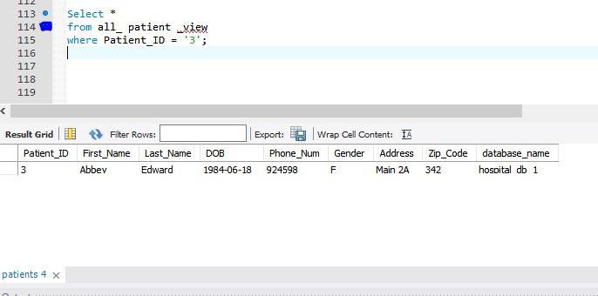

**Query 2:**

Select *

from all_ patient _view

where Database_Name = 'hospital_db_2';

**Result:**

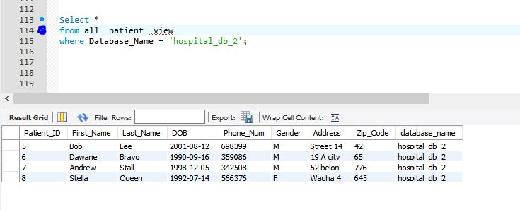

**Query 3:**

Select *

from all_ patient _view

where Database_Name = 'hospital_db_1';

**Result:**

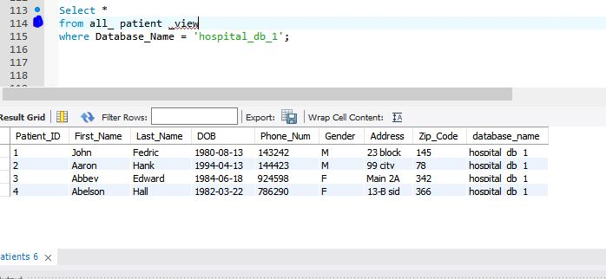

**Query 4:**

Select *

from all_ patient _view

where Gender = 'M';

**Result:**

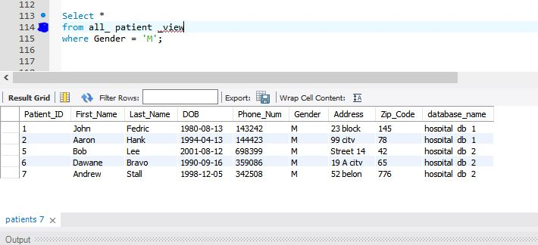

**Query 5:**

Select *

from all_ patient _view

where Gender = 'F';

**Result:**

